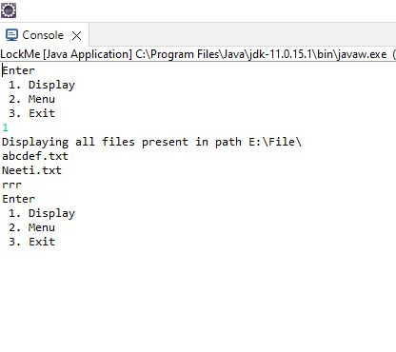

Step 1 -If we press 1 it will display all the files in the given folder

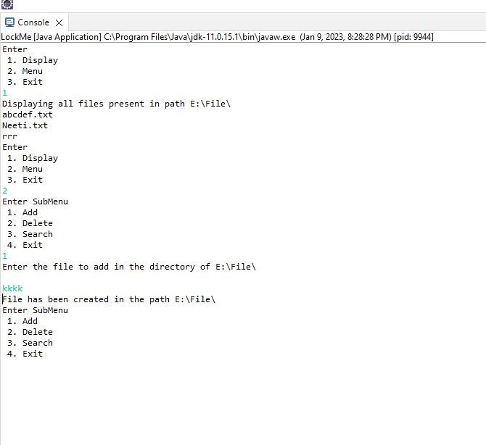

Step 2 – If we press 2 it will show the submenu

From the submenu we can select the options

* Add
* Delete
* Search
* Exit

By entering 1 we can add the file in the given path folder

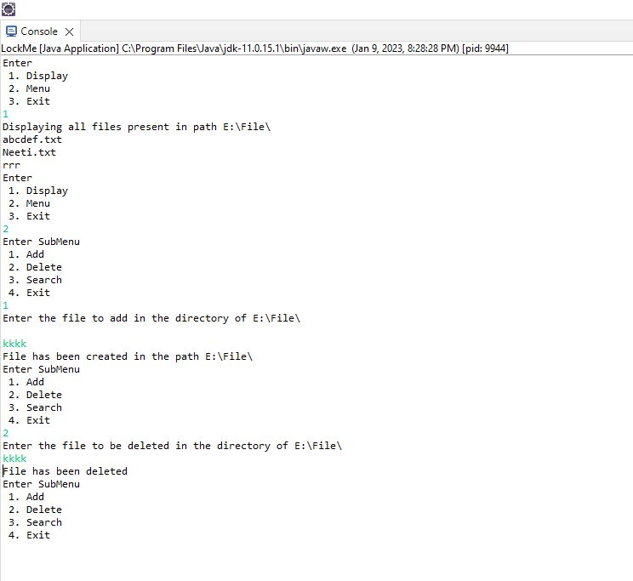

By entering 2 we can delete file from the folder

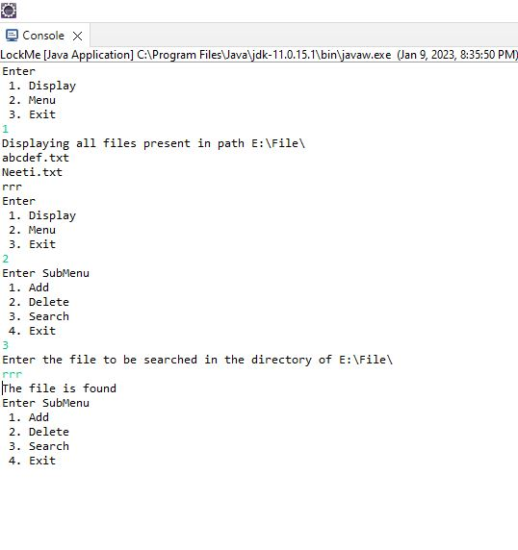

By entering 3 we can search file in the folder

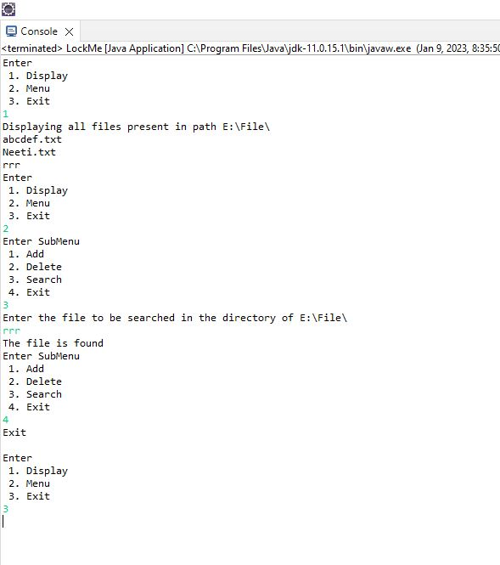

By entering 4 we can exit from SubMenu

And then it will display again Main Menu from which we can Exit by entering 3